**Option 2:**

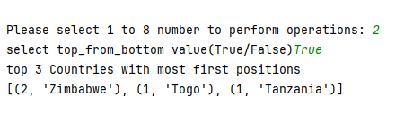

How to get this result, because follow excel file, don’t have Zimbabwe and Tanzania?

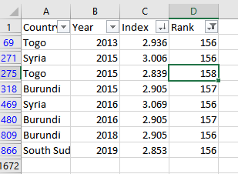

**Justification**

* There was a little bit mistake in my code. Now I have corrected it. And it working well.
* The list you provided is not the clarification of what you have mentioned in the task.
* Here is the list that I have generated through code. And now you can compare result with this list.

**This list contains country with lowest index in each year**

[('2013', [('Togo', 2.936)]),

('2015', [('Togo', 2.839)]),

('2016', [('Burundi', 2.905)]),

('2017', [('Central African Republic', 2.693)]),

('2018', [('Burundi', 2.905)]),

('2019', [('South Sudan', 2.853)]),

('2020', [('Afghanistan', 2.567)]),

('2021', [('Afghanistan', 2.523)]),

('2022', [('Afghanistan', 2.404)]),

('2023', [('Afghanistan', 1.859)])]

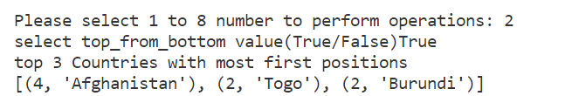

Option 3: Please explain the working function, example use Germany and India . The period value “3” counting from 2013 to 2015 or 2023 to 2021?

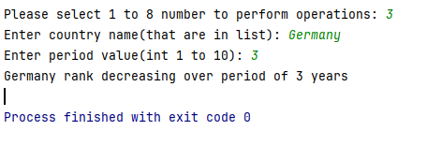

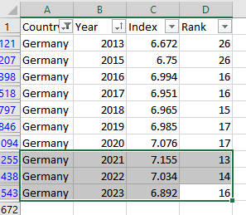

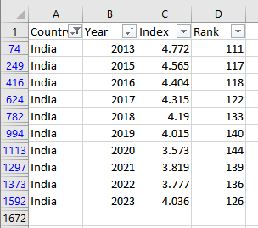

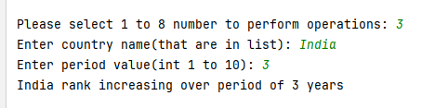

**Justification**

There was mistake in code. Now I have fixed it.

**Explanation**

The function **find_country_rank** takes in the dataset, a country name, and the start and end years for the specified period. It iterates through the data for the given country within the specified period, collects the ranks, and determines whether the rank has increased or decreased over that period.

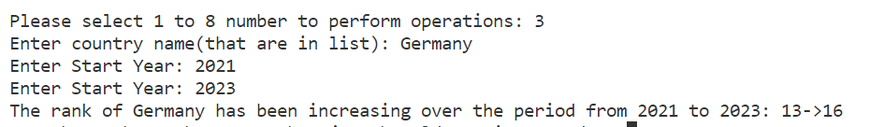

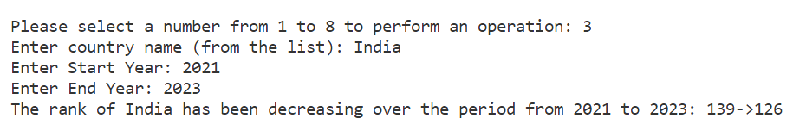

Other requirement:

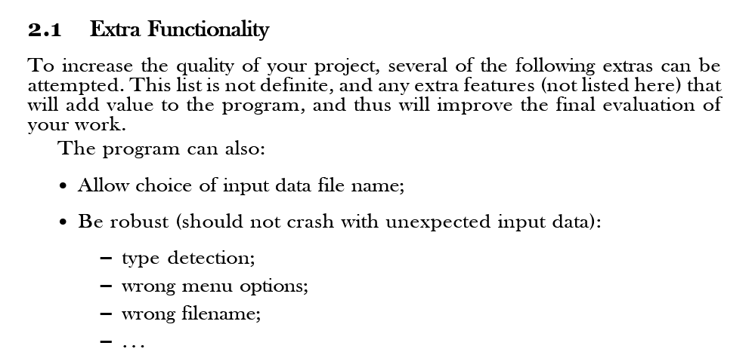

Don’t have error exception handling or input validation.

Please include errors and exceptions:

1.Syntax Errors;

2.Run time Errors;

3.Logic Errors.

**Justification**

errors and exceptions are included now